  

# GMR INSTITUTE OF TECHNOLOGY, RAJAM

(An Autonomous Institution, Accredited by NBA of AICTE, NAAC of UGC & an ISO 9001:2015 Institution)

# STEPCONE 2023

EVENT WISE BUDGET LIST

|  |  |  |  |  |  |  |  |  |  |  |
| --- | --- | --- | --- | --- | --- | --- | --- | --- | --- | --- |
| **Department of: CHEMICAL ENGINEERING**  **Faculty SPOC Nominated: Dr.Tapas Kumar Dora Mobile:**  **9438725976** | | | | | | | | | | |
| **S.NO** | **TENTATIVE EVENT** | **REGN. FEE** | **EXPECTED REGISTRATIONS** | **AMOUNT FROM REGISTRATIONS** | **OTHER COSTS** | | **PRIZE MONEY** | | | **BUDGET EXPECTED** |
| **ITEMS** | **PRICE** | **1ST** | **2ND** | **3RD** |
| 1 | CONTRAPTION | 600 | 20 | 12,000 | Judges | 10,000 | 9,000 | 6,000 | NA | **13,000**  **Required** |
| 2 | CHEM-O-ROVER | 300 | 50 | 15,000 | chemicals + Pool | 5,000 | 6,000 | 4,000 | NA | NA |
| 3 | ELECTROLIGHT | 500 | 40 | 20,000 | electrodes+ Cells+  Miscellaneous | 12,000 | 5,000 | 3,000 | NA | NA |
| 4 | SNAKE -O-MYSTERY | 300 | 60 | 15,000 | Banner + Miscellaneous | 8,000 | 4,500 | 2,500 | NA | NA |
|  |  |  |  |  |  |  |  |  |  |  |
|  |  |  |  |  |  |  |  |  |  |  |
|  | **Total** |  |  | **65,000** |  | **35,000** | **24,500** | **15,500** | **NA** | **13,000** |
|  | **ALUMINI INTERACTION** | Yes✔/No |  |  |  |  |  |  |  |  |

**Tentative Event: CONTRAPTION**

**Budget Proposed:** Rs. 40,000/-

**Co-ordinators:** A.Kushwanth(20341A0801),B.Vasu(20341A0803)

**Target Audience:** All branches

## Description:

## Contraptions turn things on its head in that where most other events seek to simplify a complex problem, Contraptions require your ability to convolute the most simplest of actions with an infinite array of steps! All you need is planning, innovation, efficiency in steps and use of materials to stay in the reckoning. It’s the only event of its kind which tests a wide range of skills of the team such as robotics, disaster proof construction, the power to innovate and impeccable implementation of ideas

## 

## YouTube link: https://www.youtube.com/watch?v=e8Voc1RynSs

**Tentative Event: CHEM-O-ROVER**

**Budget Proposed:** Rs. 15,000/-

**Co-ordinators:** G.Tharun(20341A0813),M.Madhan(20341A0822)

**Target Audience:** All branches

## Description: The chemical boat competition is always good. For this, you need water bottles, baking soda, vinegar, a nail or a drill, and either foam for the boat version or wheels for the car version. You poke a hole in the cap of the water bottle and mix the baking soda and vinegar inside. As they foam up and increase the pressure in the bottle, you'll get a jet out of the hole in the cap and that will push the bottle forward. You typically have to carry a certain weight and try to hit a certain distance of travel to decide a winner.

**Tentative Event: ELECTRO-LIGHT**

**Budget Proposed:** Rs. 20,000/-

**Co-ordinator:** P.Naveen(2135A0803),S.Srikanth(20341A0828)

## Target Audience: chem

**Description:**

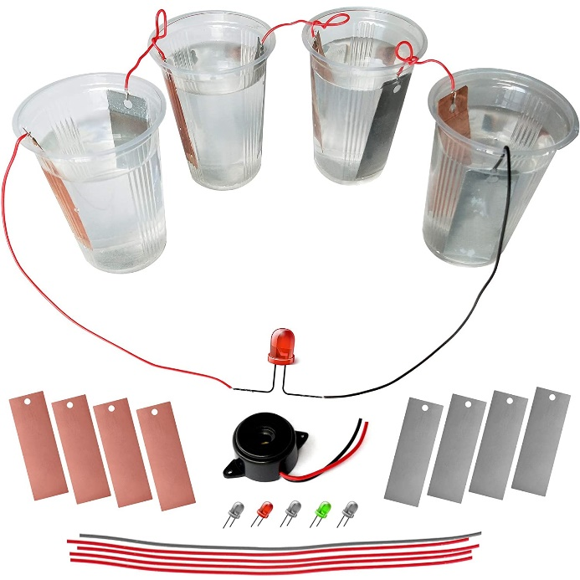Each team was asked to make a saltwater battery with the help of the materials provided. There were two rounds, the first round was to build a battery with the specified conductance/potential. In the second round, the participants were asked to make a battery with the highest potential in the given time. Each battery was then tested with LEDs.

**Tentative Event: SNAKE -O- MYSTERY**

**Budget Proposed:** Rs. 15,000/-

**Co-ordinator:** G.Neelakanteswarao(20341A0812), I.N.S.Naidu(20341A0815), K.HariKishna (20341A0821)

**Target Audience:** All branches

## Description: The event was based on the well-known game “Snake and Ladders” with a bit of a twist. Firstly, a question was asked to each participant and then if the answer was correct one chance was given to him/her to throw a dice. Then the participant moved forward to the number that appear on the dice. If the participant failed to answer the question, then he was sent back by one step.

